Day5:

LifeCycle:

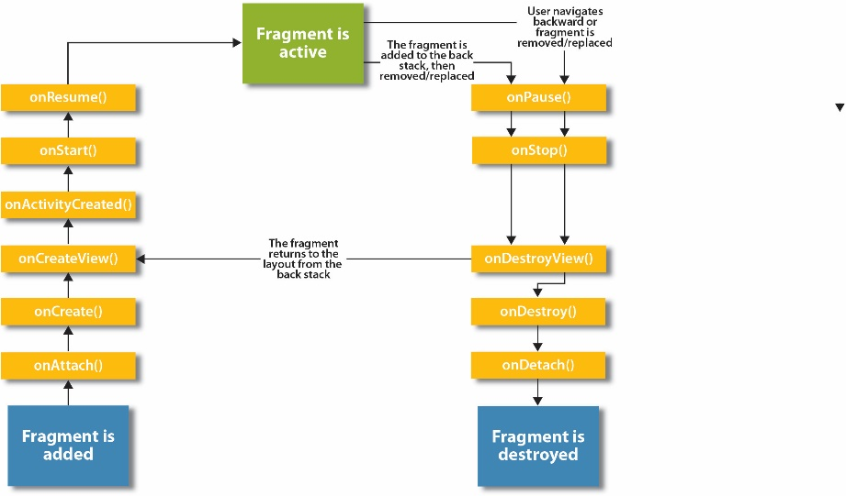

Log 用来输出到logcat。



用来输出一个toast，自己注意snytax

Set content of the current activity：

// Set the view for the activity using XML  
//setContentView(R.layout.activity_settings);

//replace the current content with the settingFragment class  
getFragmentManager().beginTransaction()  
 .replace(android.R.id.*content*,new SettingsFragment())  
 .commit();

The definition of Pref class

This class extends from the preferenceFragment.

public class SettingsFragment extends PreferenceFragment   
implements OnSharedPreferenceChangeListener{}

This is an interface to the preferences

SharedPreferences

This code adds the preference file, I think it’s just like the content setting:

addPreferencesFromResource(R.xml.*preferences*);

The xml is like the content xml in the activity

gets a [SharedPreferences](https://developer.android.com/reference/android/content/SharedPreferences.html) instance that points to the default file that is used by the preference framework in the getActivity, and the getActivity means what it shows

PreferenceManager.*getDefaultSharedPreferences*(getActivity())

[registerOnSharedPreferenceChangeListener](https://developer.android.com/reference/android/content/SharedPreferences.html#registerOnSharedPreferenceChangeListener(android.content.SharedPreferences.OnSharedPreferenceChangeListener))([SharedPreferences.OnSharedPreferenceChangeListener](https://developer.android.com/reference/android/content/SharedPreferences.OnSharedPreferenceChangeListener.html)listener)

Registers a callback to be invoked when a change happens to a preference.

[unregisterOnSharedPreferenceChangeListener](https://developer.android.com/reference/android/content/SharedPreferences.html#unregisterOnSharedPreferenceChangeListener(android.content.SharedPreferences.OnSharedPreferenceChangeListener))([SharedPreferences.OnSharedPreferenceChangeListener](https://developer.android.com/reference/android/content/SharedPreferences.OnSharedPreferenceChangeListener.html)listener)

Unregisters a previous callback.

What does this mean?

@Override  
public void onSharedPreferenceChanged(SharedPreferences prefs,   
 String key) {  
 TipCalculatorFragment tipFragment =   
 (TipCalculatorFragment) getFragmentManager()  
 .findFragmentById(R.id.*main_fragment*);  
 if (tipFragment != null) {  
 tipFragment.onResume();  
 }  
   
}

[View](https://developer.android.com/reference/android/view/View.html) onCreateView ([LayoutInflater](https://developer.android.com/reference/android/view/LayoutInflater.html) inflater,

[ViewGroup](https://developer.android.com/reference/android/view/ViewGroup.html) container,

[Bundle](https://developer.android.com/reference/android/os/Bundle.html) savedInstanceState)

Called to have the fragment instantiate its user interface view. This is optional, and non-graphical fragments can return null (which is the default implementation). This will be called between [onCreate(Bundle)](https://developer.android.com/reference/android/app/Fragment.html" \l "onCreate(android.os.Bundle)) and [onActivityCreated(Bundle)](https://developer.android.com/reference/android/app/Fragment.html#onActivityCreated(android.os.Bundle)):

public View onCreateView(LayoutInflater inflater, ViewGroup container,   
 Bundle savedInstanceState)

inflate

added in [API level 1](https://developer.android.com/guide/topics/manifest/uses-sdk-element.html#ApiLevels)

[View](https://developer.android.com/reference/android/view/View.html) inflate (int resource,

[ViewGroup](https://developer.android.com/reference/android/view/ViewGroup.html) root,

boolean attachToRoot)

Inflate a new view hierarchy from the specified xml resource. Throws [InflateException](https://developer.android.com/reference/android/view/InflateException.html) if there is an error:

// inflate the layout for this fragment  
View view = inflater.inflate(R.layout.*fragment_tip_calculator*,   
 container, false);

I think there is another way to do this.

@Override  
public void onCreateOptionsMenu(Menu menu, MenuInflater inflater) {  
 // attempt to get an instance of the SettingsFragment object  
 SettingsFragment settingsFragment = (SettingsFragment) getFragmentManager()  
 .findFragmentById(R.id.*settings_fragment*);  
   
 // display the appropriate menu  
 if (settingsFragment == null) {  
 // SettingsFragment is not in the layout  
 inflater.inflate(R.menu.*fragment_tip_calculator*, menu);  
 } else {  
 // SettingsFragment is in the layout  
 inflater.inflate(R.menu.*fragment_tip_calculator_twopane*, menu);  
 }  
}